Justin Murphy

Project 2 Part 2: Final Report

Probability & Applied Statistics

12/11/2024

**Table of Contents**

**—--------------------------------------------------------------------------------------------------------------**

* **Introduction: Page 2**
* **Chapter 1: Pages 2 - 5**
  + **Question 1: Taking the Average, Page 2 - 3**
  + **Question 2: Finding the Median, Page 3 - 4**
  + **Question 3: 1.5, Page 4 - 5**
* **Chapter 2: Pages 5 - 8**
  + **Question 4: 2.8, Page 5 - 6**
  + **Question 5: 2.10, Page 6**
  + **Question 6: 2.36, Page 6 - 7**
  + **Question 7: 2.71, Page 7**
  + **Question 8: 2.124, Page 7 - 8**
  + **Question 9: 2.146, Page 8**
* **Chapter 3: Pages 8 - 10**
  + **Question 10: 3.2, Page 8 - 9**
  + **Question 11: 3.39, Page 9 - 10**
  + **Question 12: 3.102, Page 10**

**Introduction**

**—------------------------------------------------------------------------------------------------------------------**

The data I am using today is one that I am most fond of and use a decent amount of time to try and get better at the video game Rainbow Six: Siege. In these statistics there are multiple different facets of information that can be used, like Win Percentage, how many rounds a person plays, how many rounds they win, how many rounds they lose and they include the statistics of the actual game. It helps and is influential to me since if I see I am doing bad with a character, I can practice more with that Operator until I feel like I am in a better state and position to be able to run him for the team.

Using this information is extremely simplistic and has massive amounts of information to grab values from. There is information for the past couple of years, all the way down to what operator I picked during which round of a specific map back in 2018. It was the perfect pick for this project especially since redoing the problems in a Siege type of manner is extremely fun to do, in my own opinion.

**Chapter 1**

**—------------------------------------------------------------------------------------------------------------------**

**Question 1:**

**Original Question:** N/A; Taking the Average.

In the Game of Rainbow Six: Siege, there are many statistics that are taken down during the rounds of each given game. Written down is one Player's stats from the previous season of the game. Given the statistics of a Player from Rainbow Six Siege, what are the Average amount of Deaths they have had in their career?

So, using only the Deaths Column in the CSV/Excel sheet, we can add them all up and divide by the number of values. In which we get 203.29 Deaths on Average per season of playing. I included a Scatterplot to better see the points and show they lean more so towards the 200’s.

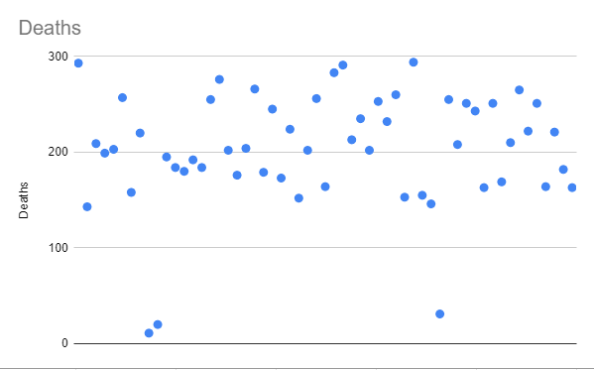

**Question 2:**

**Original Question:** N/A; Finding the Median

Using the same data as the previous question, the player wants to know the Median amount of Kills in this list of used operators, and what operator was used for those so they can focus their efforts a little more on that specific operator. What is the Median Number of Kills gotten, and under what operator has that number?

So using the data from the CSV, we can make sheets do the work for us, but if we didn’t have Excel/Sheets, we would line all of the numbers up and find the middle value from the smallest to largest. If there are two values, we take the Average of those numbers. If there is just one, that is the Median. We can see from the Data Set, that Azami with 277 Kills is the Median of the list. In addition, the plot below shows all of the data and a Trendline to show around the middle.

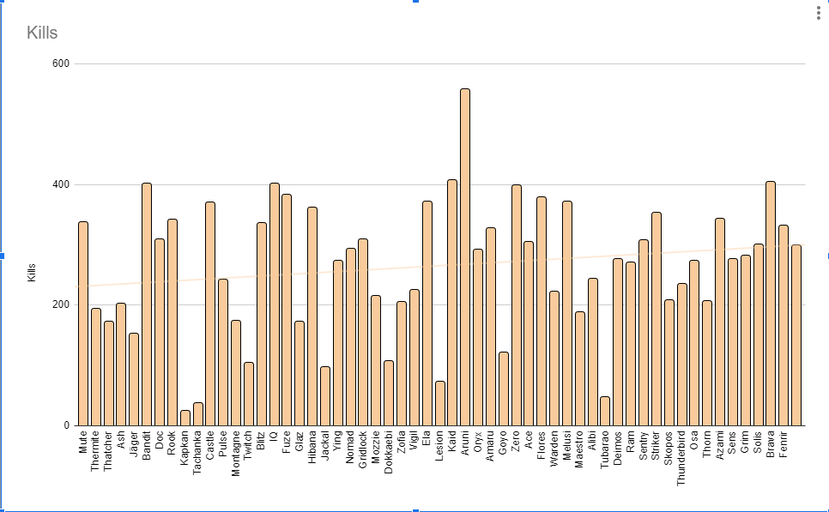

**Question 3:**

**Original Question:** Page 7, Question 1.5

Given here is the relative frequency histogram associated with Win Rate Percentages of a Rainbow Six Siege Player using all of their playtime on each Operator this season. Which of the categories identified on the horizontal axis are associated with the largest proportion of Operators used? What proportion of Operators has more than a 60% Win Percentage?

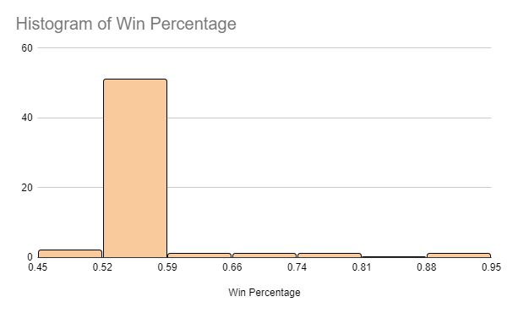

Using the Histogram above, we can see and determine that most of the Operators used this season have a Win Rate around the 0.52-0.59 percentage. So, Most operators, over 40+ of them, have been able to win rounds over 52% of the time compared to the rest of the Operators given in this list. If we then take a look at the other values, they seem to be around 3 or less operators per win rate. So, we have around 9 Operators with over a 60% Win Percentage.

Chapter 2

--------------------------------------------------------------------------------------------------------------------

**Question 4:**

**Original Question:** Question 2.8, Page 26

From using the Data Given, Multiple different Operators were used during this season of Rainbow Six Siege. There are a total of 57 Operators given that were used this season, where 4 Operators have over a 60% Win Percentage, 3 have less than 50 rounds played, and 2 of them have over 65% and less than 50 rounds played. Find the number of Operators who have under 60% Win Rate, Less than 50 rounds played, or both.

Using the Data from the Excel Spreadsheet, you can subtract 57 from 4 to get the amount of Operators who have less than 60%. Win Percentage, which is 53 and then adding the operators that have less than 50 Rounds played which is 3 Operators. Then seeing as those operators who have less than 50 rounds played all have over a 60% Win Percentage means that the total is 56 Operators for both.

**Question 5:**

**Original Question:** Page 32; Question 2.10c

Given the usage of Operators in this Season in the CSV file, it states the amount of rounds played and rounds won for each Operator that was used during the season. Seeing there are different subsections in the game that determines which Operator works for what team, the percentage of rounds used between Smoke, Mute, Thermite and Thatcher are .24, .29, .26 and .20 respectively. What are the chances that someone chose to use Thermite or Thatcher respectively? What if both were chosen?

This can be calculated by combining their percentages together, since they are exclusive choices, their percentage would be .26 + .20 = 0.46. So it would be a 46% chance that someone would choose them between these four options. Then, if two people were to choose both operators in the round, you would multiply the two probabilities together. So, it would be 0.26 * 0.20 = 0.052. So, the percentage would be 5.2% that both of these Operators would be chosen by two different people. However, one person couldn’t choose more than one operator per round, so both operators being chosen for one person would be 0% since it is impossible.

**Question 6:**

**Original Question:** Page 48; Question 2.36

Given the Game Rainbow Six: Siege, there are around 5 different steps to be performed before the end of the round stage happens. How many different ways can the round be played out, if the first step always has to happen but the other four can happen in any other way?

We would be using Permutations for the four steps past the first, since the first step always has to be at the beginning of the round. So, we would use the factorial of 4. So, it would be the initial value multiplied by one less until it gets to 1. It would look like this: $n * (n-1) * (n - 2) * ... * 1$. So we would multiply 4 * 3 * 2 * 1 to get 24. So there would be 24 different ways the round can play out and happen, given that we can’t change the first portion of the round.

**Question 7:**

**Original Question:** Page 54 - 55, Question 2.71

If we are given two different Operator Probabilities if the Operator was played in the round, where P(A) = .2 for Thermite to be played, and a P(B) = .4 for Thatcher, find the following:

P(A|B), P(B|A), P(A ∩ B|A ∪ B).

Since we are given the probabilities of the Operators being played on the team, we can assume that they are independent from each other, so to get the probability of both being played, we can multiply them together to get a 0.08 chance. Using that, we can show that 0.08/0.4 is how we can see P(A|B) = 0.2. So, the conditional probability states that if Thatcher was already picked, there is a 0.2 percent chance of Thermite also getting picked. Additionally, for P(B|A), the probability that Thatcher gets picked after Thermite is already picked would be 0.08/0.2, so it would be a 40% chance. Finally, for the union probability usage, it means if either Thatcher is picked, Thermite is picked or both are chosen for the round. So, to calculate A ∩ B we would add together the probabilities if Thermite OR Thatcher were picked alone. Then, subtract the probability that they were picked together to get 0.52 for P(A ∩ B). Then, using 0.52 and 0.08, we divide 0.08 by 0.52 to get a 0.154 probability that either Thermite is chosen alone, Thatcher is chosen alone, or both are chosen together.

**Question 8:**

**Original Question:** 2.124, Page 73

A population of People contains users who play 20% of the GIGN Operators and the other 80% of users use the Other operators. 50% of GIGN Operators and 50% of the Other Users favor the opposing side’s utility. A user chosen randomly from this population is found to dislike the other side's utility. Find the conditional probability that this user is a GIGN Operator user.

Using the Conditional Probability, we can tell that P(A) = .2, for the GIGN Users and .8 for P(B), or the Other Users. Then we have utility preference, which is .5 for both sections of the users, or P(U). Using Bayes Theorem, we use $(P(U|A) * P(A)) / P(U)$ which will equal P(A|U). However, we must calculate what Users hate the other sides utility. So, we have to have P(U), for the users that hate the other side’s utility, equal to (0.5 * 0.2) + (0.5 * 0.8). Half of each side, added together to equal 0.5, or 50% of all people who hate the other sides utility. So, we then take the previously explained Equation and put values in. $(0.5-0.2)/0.5$, which will equal 0.20, or 20% of people on the GIGN’s side that hate the other side’s utility.

**Question 9:**

**Original Question:**  2.146, Page 80

Given that all operators have a Faction and a color to go with it, what are the odds out of all the Operators that you would pull out 4 of the same color out of 60, if 5 of each operator has the same color and Faction?

Using the Event-Composition Method, we can break it down as having a total Population of 60, we are selecting 4 operators out of 5 total with the same color and faction. So, we would do the math for the probability of pulling one out with a total of 60, it being 5/60, and then continue removing one from both sides. 4/59, 3/58, 2/57 being all of the factors and then multiplying them all together, to get the probability. In conclusion, the probability that we would be able to draw 4 of the same color operator faction, would be around 0.00000966.

**Chapter 3**

---------------------------------------------------------------------------------------------------------------------

**Question 10:**

**Original Question:** 3.2, Page 90

You and another one of your teammates are playing a round where it is equally balanced of going anyway, either you get a pick on the leaderboard, or they do. If you both don’t get a pick, you get 2 points. If you both get a pick, then you get 3 points. If one of you gets a pick, but the other one doesn’t, then you lose 2 points. Give the probability distribution of how many points you’d have, Y, in one round of doing this.

So using Probability Distribution, if you BOTH get a pick, it would be ½ x ½ = ¼ of a chance to happen. Same thing with if you neither get a pick, it would also be ¼th since they use the same probability. Then, if we see you or your teammate getting a pick, but the other doesn’t, then we would add to get ½ of a chance of that happening. So, it would be:

* P(Y = 3) = ¼
* P(Y = 2) = ¼
* P(Y = -2) = ½

With a Distribution Table:

| **Points (Y)** | **Probability (P)** |
| --- | --- |
| 3 | 1/4 |
| 2 | 1/4 |
| -2 | 1/2 |

**Question 11:**

**Original Question:** 3.39, Page 111

A round of Rainbow Six Siege is planned out to always have backup plans and strategies that the team will be able to try and perform. One of these strategies has smaller tweaks in a few spots, but is just 5 identical strategies. Each of these strategies have a 15 percent chance of failing in less than 50 hours of playtime. The strategy will still work if any three of the five strategies are still working. Assume they all are independent of each other, and find the probability that exactly three of the five will last longer than 50 hours, and if these strategies will last longer than 50 hours.

Using Binomial Distribution for this, we need exactly 3 of 5 strategist to stay stalwart, so the probability that everything will still succeed is 0.85, which is 1 - the probability of failure, or 0.15. We will then take the total number of strategies, the success rate, failure rate and we know we want 3 to stay up and working against the enemy side. Using Binomial Distribution, the formula will look like, P(Y = 3) = (5 3) [5 over 3 in big parenthesis but I can’t seem to figure out how in Docs] * (0.85)^3 * (0.15)^2. Calculating all of these together, we will get a probability of 0.614 that 3 strategies will last longer than 50 hours, and a 0.0225 probability that 2 will fail. We then multiply everything together to get a probability of 0.1382 that exactly 3 strategies will last longer than 50 hours. If they last longer than 50 hours, their probability will be 0.9734 for at least 3 strategies working past 50 hours.

**Question 12:**

**Original Question:** 3.102, Page 128

A Rainbow Six: Siege Match is filled up with 10 players in the lobby. 5 of them are part of GIGN, 3 of them are a part of an Unaffiliated Team, and the other 2 are part of Team Rainbow. Three of the players are chosen one at a time without being replaced on the team after their name is drawn. What is the probability the Three players will be from the same team?

Using a Hypergeometric Probability Distribution, we will need the total number of Players in the lobby, N = 10, Each player’s team and their number of affiliates and the number of chosen players (n). We will then be using the formula and calculate from each team, which is easy for Team Rainbow, since the possibility of all three being from Team Rainbow is none, since they have two players only. Calculation from the GIGN side, it translates to 10/120, which is around 0.0833 Probability of all 3 being pulled from their team. Looking at the Unaffiliated team, it translates to 1/120, or 0.0083 probability that all of them would be chosen from this pull. So, the total probability that they are all pulled from the same team is 0.0916 chance to happen.